**YEAR 7 SOURCE PAGE – TASK 2**

**SOURCE ONE**

**The Fun of Archaeology: Discovering Something New**

|  |
| --- |
| http://www.socialstudiesforkids.com/graphics/colorbar.gif |
|  |
| http://www.socialstudiesforkids.com/graphics/colorbar.gif |

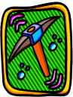Many people think that archaeology is just a bunch of digging in the dirt to see what kinds of tools people used a long time ago.

That is an important part of the study of archaeology, to be sure. But the recent discoveries at Caral in South America shed new light on civilizations in the Americas and also have caused many historians to throw long-held theories right out the window.

It seems that people lived in Caral (which was in what is now Peru) 4,600 years ago, a full 1,500 years before anybody thought they were there. At the same time the Egyptians were building the Pyramids, the people of Caral were building their own pyramids and their own grand way 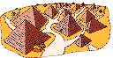of life.

What was so grand about this settlement? Archaeologists have discovered that the six pyramids uncovered so far were of different heights, each one surrounded by a group of buildings whose inhabitants had wealth and status according to where they lived. In other words, the richest and most important people lived around the tallest pyramid; the poorest people lived around the shortest pyramid, and so on.

What's the big deal about this? Historians had no idea that any of this was going on. The common belief for the longest time has been that civilizations in the Americas began much later, probably in what is now Mexico or Central America, and that it took a while for those people to create what was, in effect, social classes. But the discoveries at Caral have made those theories flat-out wrong.

This is fun stuff! It's not often that historians and archaeologists get this kind of big wake-up call. They're used to uncovering smaller details that force them to revise in small ways their versions of past events. In effect, the discoveries at Caral give historians and archaeologists a chance to create new theories and beliefs, based on newly discovered evidence.

History isn't boring. Archaeology isn't all about dirt. They're both ways of studying the past. And contrary to popular belief, the stories *are* always changing.

Reference:

<http://www.socialstudiesforkids.com/articles/archaeology/caral.htm>

**SOURCE TWO**

**Kids Guide to Archaeology**

**What is Archaeology?**

If you love learning about the past, digging in the dirt, or doing scientific experiments, archaeology may be for you. Archaeology is the study of past cultures based on the material they left behind. Scientists, called archaeologists, learn about the past by studying artefacts, buildings, and monuments. An artefact is any object made by human beings such as tools, pottery, and jewellery. Studying buildings and monuments such as the Egyptian pyramids and the Roman Colosseum can teach us many things about past cultures.

<http://www.qrcodecompanies.org/kids-guide-to-archeology.html>

**SOURCE THREE**

**The Big Dig**  
  
The process of researching and securing a dig site can take years. Digging is the field work of archaeology. On occasion, archaeologists might need to move earth with bulldozers and backhoes. Usually, however, archaeologists use tools such as brushes, hand shovels, and even toothbrushes to scrape away the earth around artifacts.  
  
The most common tool that archaeologists use to dig is a flat trowel. A trowel is a hand-held shovel used for smoothing as well as digging. Archaeologists use trowels to slowly scrape away soil. For very small or delicate remains, archaeologists might also dig with dental picks, spoons, or very fine blades. Often, they will sift dirt through a fine mesh screen. Tiny remains, such as beads, can often be found this way.  
  
Archaeologists take lots of notes and photographs along each step of the process. Sometimes they include audio and video recordings. Global positioning system (GPS) units and data from geographic information systems (GIS) help them map the location of various features with a high level of precision.  
  
When archaeologists find remains, they are often broken or damaged after hundreds or even thousands of years underground. Sunlight, rain, soil, animals, bacteria, and other natural processes can cause artifacts to erode, rust, rot, break, and warp.   
  
Sometimes, however, natural processes can help preserve materials. For example, sediments from floods or volcanic eruptions can encase materials and preserve them. In one case, the chill of an Alpine glacier preserved the body of a man for more than 5,300 years! The discoverer of the so-called “Iceman,” found in the Alps between Switzerland and Italy, thought he was a recent victim of murder, or one of the glacier’s crevasses. Forensic archaeologists studying his body were surprised to learn that he was a murder victim—the crime just took place more than 5,000 years ago.

<http://education.nationalgeographic.com.au/education/encyclopedia/archaeology/?ar_a=1>

**SOURCE FOUR**

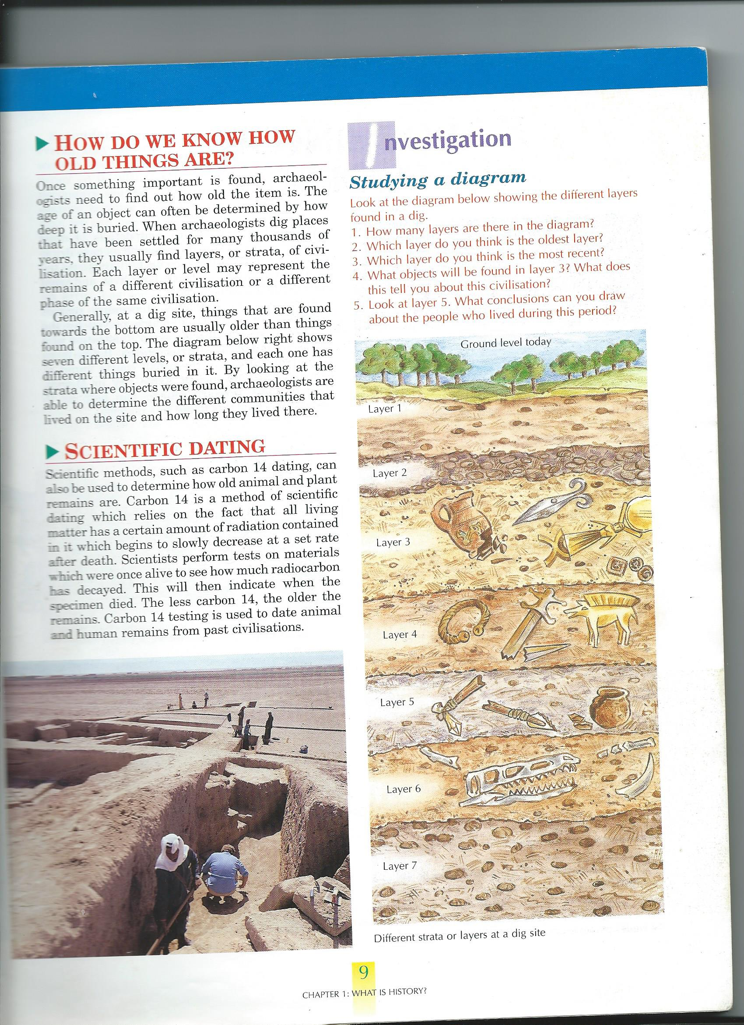

Ciavarella. G & Calandra. A. (2000) SOSE 1 – Studies of Society & Environment – Second Edition, John Wiley & Sons, Milton, Queensland.